Is it a Half?
Brief description of focus of video: These next video clips (#3a, 3b, 3c) are taken from the next five minutes of class. Video clips 3a, 3b, and 3c reveal their emerging ways of thinking, and revisions to earlier ways of thinking.
After this set of clips, the two students work for five more minutes and then the class returns to a whole class discussion.

Clip 3a
2:59 – 3:28: Developing a counting strategy
R: Okay, cool. Okay, well keep going. What’s the next one you want to do?
G1: That one’s not equal. [pointing to new example]
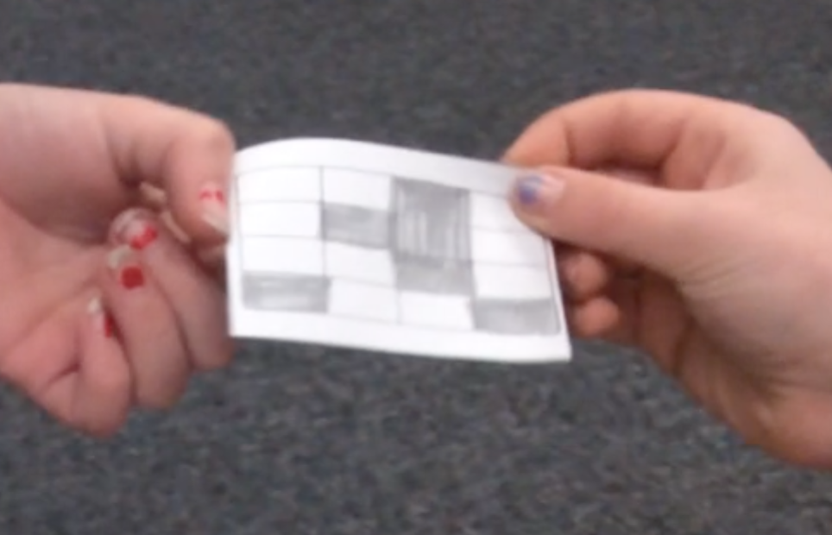
G2: Yeah, because it’s all like over the place [pointing to shaded squares that are not all touching]. [G1: It’s all over the place.] And, and there’s one like one [inaudible] shaded and one [inaudible] shaded…
G1: When you see it you should know what it was.
03:10
R: So, just by looking at it, it doesn’t look like the same amount of area is shaded as not shaded, but how could we know for sure? Because it’s really hard to tell.
G1: We could actually count. 1, 2, 3, 4, 5, 6 [counting the shaded squares on the paper] 1, 2, 3, 4, 5, 6, 7 [counting the nonshaded squares on the paper]. You already know you’re over so that means it is not going to be a half.
R: Oh, okay.
3:28

Clip 3b Using the counting strategy, and continuing to make sense.
05:29 – 6:03
[G2 hands G1 a new example to look at]

G1: [counting nonshaded boxes] 1, 2, 3, 4, 5, 6, 7, 8. [counting shaded boxes] 1, 2, 3, 4, 5, 6, 7, 8. It is equal because if you put them in the right order than you would know it’s equal.
05:43
G2: Like if you switched them around?
G1: Yeah.
R: Okay.
G1: So I think it’s equal.
R: You both agree?
G1: [looking at G2] Do we both agree?
G2: Yes.
R: Yes, okay.
G2: Because there’s like two together...
G1: [counting shaded and nonshaded boxes to herself. Looks up when done.] I was just making sure.
R: Great. That’s a great way to make sure.
06:03

Clip 3c Argumentation and error detection
6:42 – 7:13
[G2 hands G1 another example to look at]

G1: I think it’s not half because [G2: there’s more than] here’s, the darker ones are more than that one [G2: yeah, there are more] and I can tell because there’s 6 in the middle and there’s 6 on the side. Wait, no, it’s equal [smiles] hmmhm.
G2: Wait…
07:00
G1: It is because look 6 [pointing to shaded boxes] and then 6 in the middle [pointing to nonshaded boxes] and then 2 here [pointing to shaded boxes] and then 2 here [pointing to nonshaded boxes]. So, I think it’s a half. You can say what you think.
7:08
R: Cat, what do you think?
G1: What do you think?
R: This is a really interesting one, huh?
7:13

